HUMAN FACE

EMOTION IN 3D

A

*Mini Project Report Submitted in partial fulfillment of the*

*Requirements for the award of the Degree of*

BACHELOR OF ENGINEERING

IN

INFORMATION TECHNOLOGY

By

SHAIK MOHAMMED SAMEER, 1602-20-737-168

**JARUPLA ARUNA, 1602-20-737-125**

CHIMMI MAHESH, 1602-20-737-143



**Department of Information Technology**

**Vasavi College of Engineering (Autonomous)**

VASAVI COLLEGE OF ENGINEERING (AUTONOMOUS)

(AFFILIATED TO OSMANIA UNIVERSITY)

HYDERABAD-500030

**Department of Information Technology**



DECLARATION BY CANDIDATE

We,**SHAIK MOHAMMED SAMEER, JARUPLA ARUNA,CHIMMI MAHESH,**bearing hall ticket number,**1602-20-737-168 ,1602-20-737-125 ,1602-20-737-143** here by declare that the project report entitled **”HUMAN FACE EMOTION IN 3D”** Department of Information Technology, Vasavi College of Engineering,Hyderabad, is submitted in partial fulfillment of the requirement for the award of the degree of **Bachelor of Engineering** in **Information Technology**

This is a record of bonafide work carried out by me and the results embodied in this project report has not been submitted to any other university or institute for the award of any other degree or diploma.

SHAIK MOHAMMED SAMEER 1602-20-737-168

**JARUPLA ARUNA 1602-20-737-125**

**CHIMMI MAHESH 1602-20-737-143**

VASAVI COLLEGE OF ENGINEERING (AUTONOMOUS)

(AFFILIATED TO OSMANIA UNIVERSITY)

HYDERABAD-500030

**Department of Information Technology**



BONAFIDE CERTIFICATE

This is to certify that the project entitled “HUMAN FACE EMOTION IN 3D ” being submitted by **SAMEER, ARUNA, MAHESH** bearing **1602-20-737-168, 1602-20-737-125**,

**1602-20-737-143**, in partial fulfillment of the requirements for the completion of MINI PROJECT of Bachelor of Engineering in Information Technology is are cord of bonafide work carried out by them under my guidance.

Internal Guide External Examiner Dr.K Ram Mohan Rao

Ms. B Leelavathy HOD,IT

ACKNOWLEDGEMENT

We thank the department of INFORMATION TECHNOLOGY,for introducing the subject “MiniProject-2” in BE fifth semester.

We would also like to show our appreciation to our Honorable principal, Dr S V Ramana sir ,our HOD K. Ram Mohan Rao for supporting us and our mini project Assistant professor, Ms Leelavathy mam,for letting us properly understand the process of doing a project and for providing valuable insight and expertise that has greatly assisted us in the making of the project.

TABLE OF CONTENTS:

1. INTRODUCTION
   1. PURPOSE
   2. INTENDED AUDIENCE
   3. PRODUCT SCOPE
   4. PROBLEM DEFINITON
2. RELATED WORK
3. PROPOSED WORK
   1. USE CASES
   2. UI PROTOTYPES OR SCREENSHOTS
   3. ARCHITECTURE
   4. DESIGN
   5. IMPLEMENTATION
      1. MODULES
      2. ALGORITHMS USED
      3. CODE AND GITHUB LINKS
   6. TESTING
4. RESULTS
5. DISCUSSION AND FUTURE WORK
6. REFERENCES

**ABSTRACT**

Face detection, which is an effortless task for humans, is complex to perform on machines. The interaction between human beings and computers will be more natural if computers are able to perceive and respond to human non-verbal communication such as emotions. This project uses a combination of techniques in two topics; face detection and recognition. Emotions are reflected from speech, hand and gestures of the body and through facial expressions. The main objective of this project is to make a web app to upload an image to detect emotions and make a 3d render face.

CHAPTER 1 INTRODUCTION

* 1. PURPOSE

Nowadays, more and more intelligent systems are using emotion recognition models to improve their interaction with humans. This is important, as the systems can adapt their responses and behavioral patterns according to the emotions of the humans and make the interaction more natural.

Modern 3D modeling provides a level of design depth that rough sketches or 2D designs cannot, such as improved control over details. It also lets engineers explore the physical aspects of a design without surrendering to physical limitations.

* 1. **INTENDED AUDIENCE**

The intended audience for this project is everyone who wants to detect emotions and do some work on it. This technology can be applied to fields like **security, biometrics, law enforcement, etc., for tracking and surveillance purposes.** It proposes a set of research scenarios of emotion recognition applications in the following domains:  **software engineering, website customization, education, and gaming.**

* 1. PRODUCT SCOPE

Now we have designed a website. We are planning to develop an application.

It offers tremendous scope to **human computer interaction, robotics, health care, biometric security and behavioral modeling**.

* 1. PROBLEM DEFINITION

With the recent advancement of computer vision and AI/ML techniques, identification of human faces is no longer a challenging task. However, creating a human face with captured expressions, movements, voice and other features in real time videos is still a challenging task. Design a prototype system with advance techniques of image recognition and AI/ML to identify humans in real time video. The prototype system must render the image of identified person in the video such that the face orientation changes dynamically with the body movement. Effects like face expressions, movements must be captured effectively to give feeling of real human face.

CHAPTER 2 RELATED WORK

Many of today’s new and innovative artificial intelligence (AI) applications use CNN- based deep learning technology to capture, interpret, and analyze various kinds of video, audio, and text data. A convolutional neural network is a type of deep learning algorithm that is most often applied to analyze and learn visual features from large amounts of data. While primarily used for image-related AI applications, CNNs can be used for other AI tasks, including natural language processing and in recommendation engines.

CHAPTER 3 PROPOSED WORK–

* 1. **Use cases–**

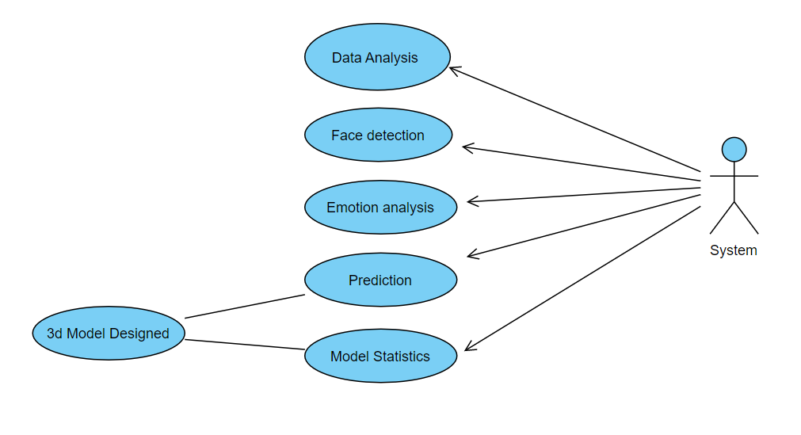

**3.2 UI prototypes or screenshots--**

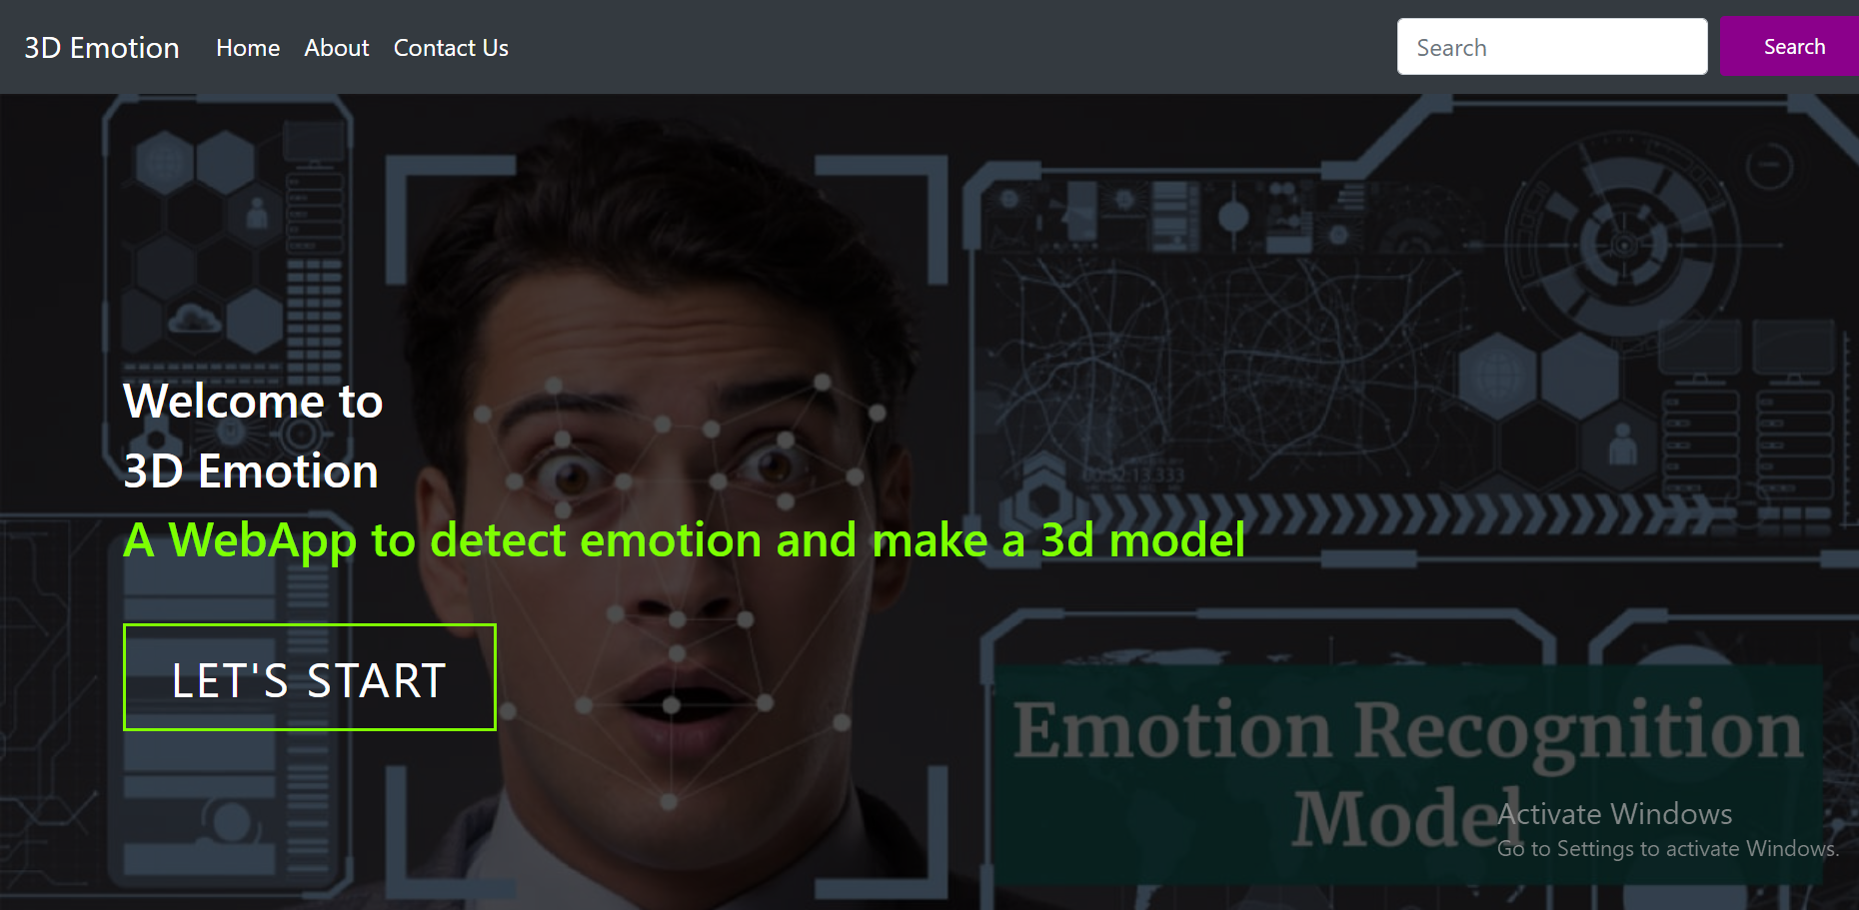

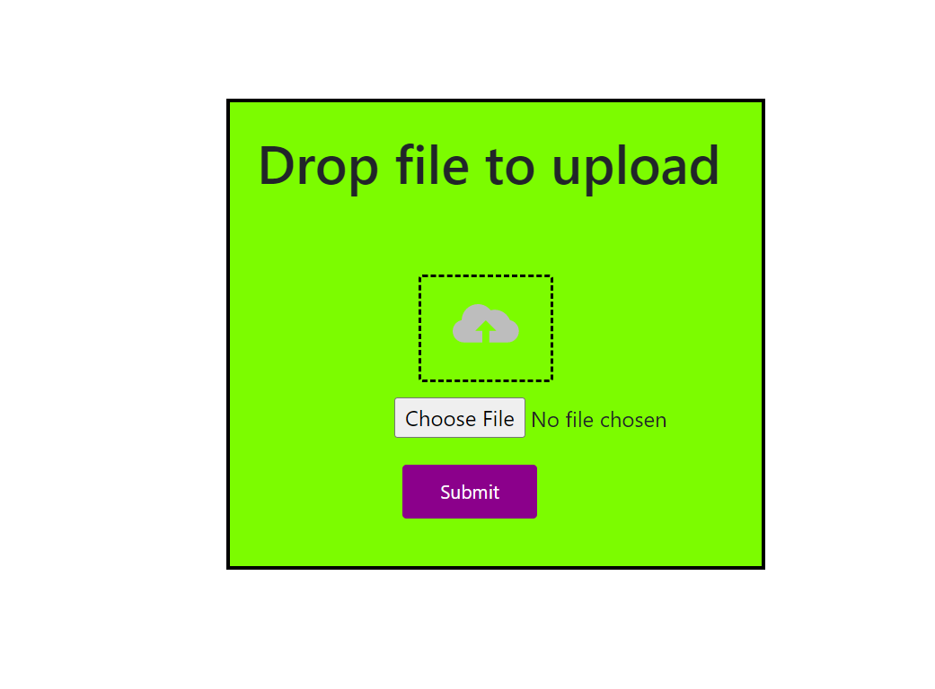

**3.3 Architecture and Technology used–**

**Technology used –**

Front-end : HTML, CSS,Flask

Back-end Modules used: Tensor flow, Keras, CNN

Tensor flow: The TensorFlow platform helps you implement best practices for data automation, model tracking, performance monitoring, and model retraining. Using production-level tools to automate and track model training over the lifetime of a product, service, or business process is critical to success.

Keras: Keras is used for creating deep models which can be productized on smartphones. Keras is also used for distributed training of deep learning models. Keras is used by companies such as Netflix, Yelp, Uber, etc.

3.4 Design –

DATA FLOW DIAGRAM--

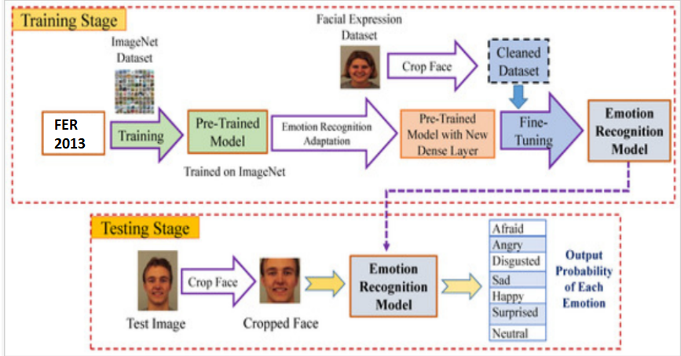

3.5 Implementation

**3.5.1 Modules :**

The various intents the face and signature classifier is trained on are –

3.5.1.1–Upload image –

If no image is uploaded then a page will be redirected to the same screen.

3.5.1.2– detect emotions–

User has to upload image then the system will predict the emotion using trained model.

* + - 1. – 3D Modelling–

After predicting emotion the image will be send to BFM model which will make it into 3d.

**3.5.2 Algorithm used:**

CNN: A CNN is a kind of network architecture for deep learning algorithms and is specifically used for image recognition and tasks that involve the processing of pixel data. There are other types of neural networks in deep learning, but for identifying and recognizing objects, CNNs are the network architecture of choice.

>> Data Analysis:

* Image converting into grayscale using CV2
* Resizing gray Image to 48x48 pixels
* Reshaping image using Numpy

>> Face Detection:

* Detecting faces using “haarcascade\_frontalface\_default.xml”.
* Cropping image to face shape.

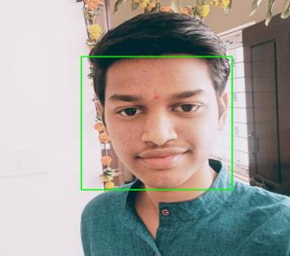 PrivateTest_7366737

>> Emotion Analysis:

* Loading model structure using json file.
* Predicting emotion using CNN trained model (model.h5)

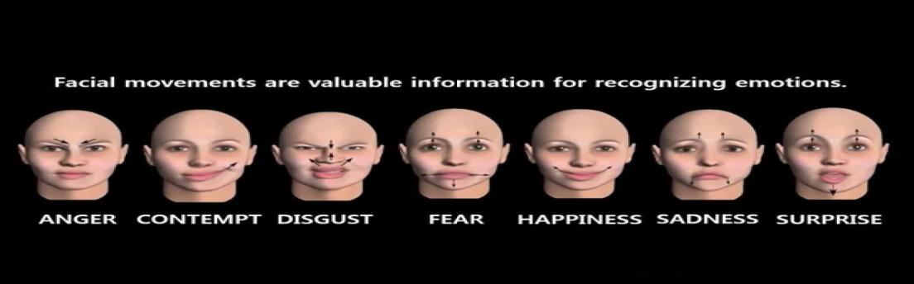

>> 3D Model :

* Loading BFM model for making 3d face using torch, aspose-3d and mediapipe.

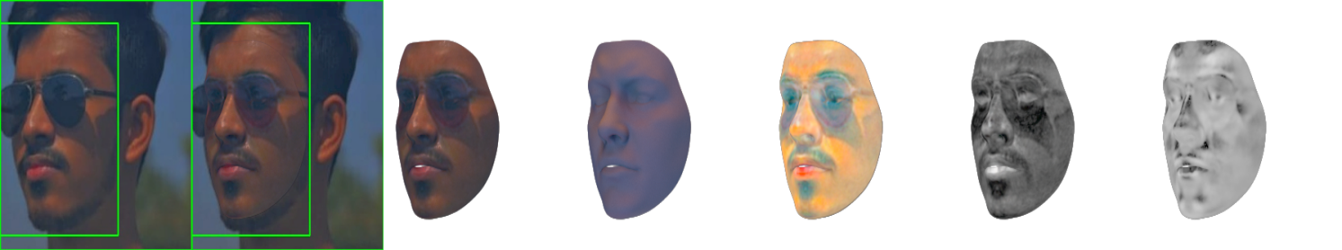

**3.5.3 Code:**

// APP.PY

from flask import Flask,render\_template,request,redirect

from flask\_ngrok import run\_with\_ngrok

import sys

import os

from os.path import join, dirname, realpath

from werkzeug.utils import secure\_filename

import cv2

import tensorflow as tf

from keras.preprocessing import image

from keras.models import load\_model,model\_from\_json

import numpy as np

import jinja2

import aspose.threed as a3d

from optimizer import Optimizer

from config import Config

config = Config()

config.fillFromDicFile('/content/gdrive/MyDrive/ColabNotebooks/NextFace/optimConfig.ini')

config.device = 'cuda'

config.path = '/content/gdrive/MyDrive/ColabNotebooks/NextFace/baselMorphableModel/'

UPLOAD\_FOLDER = '/content/gdrive/MyDrive/ColabNotebooks/NextFace/static/'

app = Flask(\_\_name\_\_,template\_folder='/content/gdrive/MyDrive/ColabNotebooks/NextFace/templates',static\_folder='/content/gdrive/MyDrive/ColabNotebooks/NextFace/static')

run\_with\_ngrok(app)

app.config['UPLOAD\_FOLDER'] = UPLOAD\_FOLDER

app.config['SEND\_FILE\_MAX\_AGE\_DEFAULT'] = 1

app.secret\_key = 'sameer'

!rm -rf '/content/gdrive/MyDrive/ColabNotebooks/NextFace/static/output/'

@app.route('/')

def main():

    return render\_template('index.html')

@app.route('/predict',  methods=['POST', 'GET'])

def uploadFile():

    if request.method == 'POST':

        if 'uploaded-file' not in request.files:

            return render\_template('index.html')

        uploaded\_img = request.files['uploaded-file']

        if uploaded\_img.filename == '':

            return render\_template('index.html')

        uploaded\_img.save('static/file.jpg')

        img1 = cv2.imread('static/file.jpg')

        gray = cv2.cvtColor(img1, cv2.COLOR\_BGR2GRAY)

        cascade = cv2.CascadeClassifier('haarcascade\_frontalface\_default.xml')

        faces = cascade.detectMultiScale(gray, 1.1, 3)

        for x,y,w,h in faces:

            cv2.rectangle(img1, (x,y), (x+w, y+h), (0,255,0), 2)

            cropped = img1[y:y+h, x:x+w]

        cv2.imwrite('static/after.jpg', img1)

        try:

            cv2.imwrite('static/cropped.jpg', cropped)

        except:

            pass

        try:

            image = cv2.imread('static/cropped.jpg', 0)

        except:

            image = cv2.imread('static/file.jpg', 0)

        image = tf.keras.utils.load\_img('/content/gdrive/MyDrive/ColabNotebooks/NextFace/static/cropped.jpg',target\_size = (48,48),color\_mode = "grayscale")

        image = np.array(image)

        image = image/255.0

        image = np.reshape(image, (1,48,48,1))

        model = model\_from\_json(open("emotion\_model1.json", "r").read())

        model.load\_weights('model.h5')

        prediction = model.predict(image)

        label\_dict = {0:'Angry',1:'Disgust',2:'Fear',3:'Happy',4:'Neutral',5:'Sad',6:'Surprise'}

        prediction = list(prediction[0])

        img\_index = prediction.index(max(prediction))

        final\_prediction=label\_dict[img\_index]

        imagePath = '/content/gdrive/MyDrive/ColabNotebooks/NextFace/static/file.jpg'

        outputDir = '/content/gdrive/MyDrive/ColabNotebooks/NextFace/static/output/'

        optimizer = Optimizer(outputDir ,config)

        optimizer.run(imagePath)

        scene=a3d.Scene.from\_file("static/output/mesh0.obj")

        scene.save("static/output/result.glTF")

        return render\_template('predict.html', data=final\_prediction)

@app.route('/contact')

def main2():

    return render\_template('contact.html')

@app.route('/about')

def main3():

return render\_template('about.html')

if \_\_name\_\_ == "\_\_main\_\_":

app.run()

// INDEX.HTML

{% extends 'base.html' %}

{% block body %}

<section id="hero">

  <div class="hero container">

    <div>

      <h5>Welcome to <span></span></h5>

      <h5>3D Emotion<span></span></h5>

      <h5>A WebApp to detect emotion and make a 3d model <span></span></h5>

      <a href="#carouselExampleIndicators" type="button" class="cta">Let's Start</a>

    </div>

  </div>

</section>

<div class="container-fluid">

  <div id="carouselExampleIndicators" class="carousel slide carousel-fade" data-ride="carousel" data-interval="1000">

    <div class="carousel-inner">

      <div class="carousel-item active">

        <img class="d-block w-100" src="{{ url\_for('static', filename='home1.webp') }}" alt="First slide" width=auto

          height="400">

        <h4 style="color:black;text-align: center;">Valid Emotions</h4>

      </div>

      <div class="carousel-item">

        <img class="d-block w-100" src="{{ url\_for('static', filename='home2.jpeg') }}" alt="Second slide" width=auto

          height="400">

        <h4 style="color:black; text-align: center;">Emotion Detection</h4>

      </div>

      <div class="carousel-item">

        <img class="d-block w-100" src="{{ url\_for('static', filename='11.jfif') }}" alt="Third slide" width=auto

          height="400">

        <h4 style="color:black; text-align: center;">3D Conversion</h4>

      </div>

    </div>

    <a class="carousel-control-prev" href="#carouselExampleIndicators" role="button" data-slide="prev">

      <span class="carousel-control-prev-icon" aria-hidden="true"></span>

      <span class="sr-only">Previous</span>

    </a>

    <a class="carousel-control-next" href="#carouselExampleIndicators" role="button" data-slide="next">

      <span class="carousel-control-next-icon" aria-hidden="true"></span>

      <span class="sr-only">Next</span>

    </a>

  </div>

</div>

<div class="container">

<div class="box">

  <div class="frame">

    <div class="center">

      <div class="title">

        <h1>Drop file to upload</h1>

      </div>

      <div class="dropzone">

          <img src="http://100dayscss.com/codepen/upload.svg" class="upload-icon" />

          <form method="POST" enctype="multipart/form-data" action="{{url\_for('uploadFile')}}">

            <input type="file" class="upload" id="myFile" name="uploaded-file" >

            <input type="submit" class="btn submit" value="Submit">

          </form>

      </div> </div>

  </div>

</div>

</div>

{% endblock body %}

// BASE.HTML

<!doctype html>

<html lang="en">

<head>

  <!-- Required meta tags -->

  <meta charset="utf-8">

  <meta name="viewport" content="width=device-width, initial-scale=1, shrink-to-fit=no">

  <link rel="stylesheet" href="index1.css">

  <!-- Bootstrap CSS -->

  <link rel="stylesheet" href="https://cdn.jsdelivr.net/npm/bootstrap@4.1.3/dist/css/bootstrap.min.css"

    integrity="sha384-MCw98/SFnGE8fJT3GXwEOngsV7Zt27NXFoaoApmYm81iuXoPkFOJwJ8ERdknLPMO" crossorigin="anonymous">

    <link rel="stylesheet" href="{{ url\_for('static', filename='index1.css') }}">

    <title>HumanFace</title>

    <link href="https://fonts.googleapis.com/css?family=Roboto:400,100,300,700" rel="stylesheet" type="text/css">

    <link rel="stylesheet" href="https://stackpath.bootstrapcdn.com/font-awesome/4.7.0/css/font-awesome.min.css">

    <script defer="" referrerpolicy="origin"

        src="/cdn-cgi/zaraz/s.js?z="></script>

    <script nonce="837d7b34-98f7-4892-b860-8144b79c3500">(function (w, d) { !function (cM, cN, cO, cP) { cM.zarazData = cM.zarazData || {}; cM.zarazData.executed = []; cM.zaraz = { deferred: [], listeners: [] }; cM.zaraz.q = []; cM.zaraz.\_f = function (cQ) { return function () { var cR = Array.prototype.slice.call(arguments); cM.zaraz.q.push({ m: cQ, a: cR }) } }; for (const cS of ["track", "set", "debug"]) cM.zaraz[cS] = cM.zaraz.\_f(cS); cM.zaraz.init = () => { var cT = cN.getElementsByTagName(cP)[0], cU = cN.createElement(cP), cV = cN.getElementsByTagName("title")[0]; cV && (cM.zarazData.t = cN.getElementsByTagName("title")[0].text); cM.zarazData.x = Math.random(); cM.zarazData.w = cM.screen.width; cM.zarazData.h = cM.screen.height; cM.zarazData.j = cM.innerHeight; cM.zarazData.e = cM.innerWidth; cM.zarazData.l = cM.location.href; cM.zarazData.r = cN.referrer; cM.zarazData.k = cM.screen.colorDepth; cM.zarazData.n = cN.characterSet; cM.zarazData.o = (new Date).getTimezoneOffset(); if (cM.dataLayer) for (const cZ of Object.entries(Object.entries(dataLayer).reduce(((c\_, da) => ({ ...c\_[1], ...da[1] }))))) zaraz.set(cZ[0], cZ[1], { scope: "page" }); cM.zarazData.q = []; for (; cM.zaraz.q.length;) { const db = cM.zaraz.q.shift(); cM.zarazData.q.push(db) } cU.defer = !0; for (const dc of [localStorage, sessionStorage]) Object.keys(dc || {}).filter((de => de.startsWith("\_zaraz\_"))).forEach((dd => { try { cM.zarazData["z\_" + dd.slice(7)] = JSON.parse(dc.getItem(dd)) } catch { cM.zarazData["z\_" + dd.slice(7)] = dc.getItem(dd) } })); cU.referrerPolicy = "origin"; cU.src = "/cdn-cgi/zaraz/s.js?z=" + btoa(encodeURIComponent(JSON.stringify(cM.zarazData))); cT.parentNode.insertBefore(cU, cT) };["complete", "interactive"].includes(cN.readyState) ? zaraz.init() : cM.addEventListener("DOMContentLoaded", zaraz.init) }(w, d, 0, "script"); })(window, document);</script>

  </head>

<body>

    <nav class="navbar navbar-expand-lg navbar-dark bg-dark">

        <a class="navbar-brand" href="/">3D Emotion</a>

        <button class="navbar-toggler" type="button" data-toggle="collapse" data-target="#navbarSupportedContent"

          aria-controls="navbarSupportedContent" aria-expanded="false" aria-label="Toggle navigation">

          <span class="navbar-toggler-icon"></span>

        </button>

        <div class="collapse navbar-collapse" id="navbarSupportedContent">

          <ul class="navbar-nav mr-auto">

            <li class="nav-item active">

              <a class="nav-link" href="/">Home <span class="sr-only">(current)</span></a>

            </li>

            <li class="nav-item active">

              <a class="nav-link" href="/about">About</a>

            </li>

            <li class="nav-item active">

              <a class="nav-link" href="/contact">Contact Us</a>

            </li>

          </ul>

          <form class="form-inline my-2 my-lg-1">

            <input class="form-control mr-sm-2" type="search" placeholder="Search" aria-label="Search">

            <button class="btn btn-outline-success my-2 my-sm-0" type="submit">Search</button>

          </form>

        </div>

      </nav>

    {% block body %}

    {% endblock body %}

</body>

  <script src="js/jquery.min.js"></script>

    <script src="js/popper.js"></script>

    <script src="js/bootstrap.min.js"></script>

    <script src="js/jquery.validate.min.js"></script>

    <script src="js/main.js"></script>

    <script defer=""

        src="https://static.cloudflareinsights.com/beacon.min.js/vaafb692b2aea4879b33c060e79fe94621666317369993"

        integrity="sha512-0ahDYl866UMhKuYcW078ScMalXqtFJggm7TmlUtp0UlD4eQk0Ixfnm5ykXKvGJNFjLMoortdseTfsRT8oCfgGA=="

        data-cf-beacon="{&quot;rayId&quot;:&quot;773ef019bc5979f4&quot;,&quot;token&quot;:&quot;cd0b4b3a733644fc843ef0b185f98241&quot;,&quot;version&quot;:&quot;2022.11.3&quot;,&quot;si&quot;:100}"

        crossorigin="anonymous"></script>

  <script src="https://code.jquery.com/jquery-3.3.1.slim.min.js"

    integrity="sha384-q8i/X+965DzO0rT7abK41JStQIAqVgRVzpbzo5smXKp4YfRvH+8abtTE1Pi6jizo"

    crossorigin="anonymous"></script>

  <script src="https://cdn.jsdelivr.net/npm/popper.js@1.14.3/dist/umd/popper.min.js"

    integrity="sha384-ZMP7rVo3mIykV+2+9J3UJ46jBk0WLaUAdn689aCwoqbBJiSnjAK/l8WvCWPIPm49"

    crossorigin="anonymous"></script>

  <script src="https://cdn.jsdelivr.net/npm/bootstrap@4.1.3/dist/js/bootstrap.min.js"

    integrity="sha384-ChfqqxuZUCnJSK3+MXmPNIyE6ZbWh2IMqE241rYiqJxyMiZ6OW/JmZQ5stwEULTy"

    crossorigin="anonymous"></script>

</body>

</html>

// ABOUT.HTML

{% extends 'base.html' %}

{% block body %}

    <header class="bg-primary text-center py-5 mb-4">

          <h1 class="fw-light text-white">Meet the Team</h1>

      </header>

    <div class="container">

        <div class="row">

          <!-- Team Member 1 -->

          <div class="col-xl-3 col-md-6 mb-4">

            <div class="card border-0 shadow">

              <img src="https://source.unsplash.com/TMgQMXoglsM/500x350" class="card-img-top" alt="...">

              <div class="card-body text-center">

                <h5 class="card-title mb-0">Shaik Mohammed Sameer</h5>

                <div class="card-text text-black-50">1602-20-737-168<br>160220l033@gmail.com</div>

              </div>

            </div>

          </div>

          <!-- Team Member 2 -->

          <div class="col-xl-3 col-md-6 mb-4">

            <div class="card border-0 shadow">

              <img src="https://source.unsplash.com/9UVmlIb0wJU/500x350" class="card-img-top" alt="...">

              <div class="card-body text-center">

                <h5 class="card-title mb-0">Chimmi Mahesh</h5>

                <div class="card-text text-black-50">1602-20-737-143<br>mahesh143@gmail.com</div>

              </div>

            </div>

          </div>

          <!-- Team Member 3 -->

          <div class="col-xl-3 col-md-6 mb-4">

            <div class="card border-0 shadow">

              <img src="https://source.unsplash.com/sNut2MqSmds/500x350" class="card-img-top" alt="...">

              <div class="card-body text-center">

                <h5 class="card-title mb-0">Jarpula Aruna</h5>

                <div class="card-text text-black-50">1602-20-737-125<br>aruna125@gmail.com</div>

              </div>

            </div>

          </div>

      </div>

{% endblock body %}

\_\_\_\_\_\_\_\_\_\_\_\_\_\_\_\_\_\_\_\_\_\_\_\_\_\_\_\_\_\_\_\_\_\_\_\_\_\_\_\_\_\_\_\_\_\_\_\_\_\_\_\_\_\_\_\_\_\_\_\_\_\_\_\_\_\_\_\_\_\_\_\_\_\_\_\_\_\_\_\_\_\_\_\_\_\_\_\_\_

// CONTACT.HTML

{% extends 'base.html' %}

{% block body %}

<section class="ftco-section">

    <div class="container">

        <div class="row justify-content-center">

                <div class="col-md-10">

                    <div class="wrapper">

                        <div class="row no-gutters">

                            <div class="col-md-6">

                                <div class="contact-wrap w-100 p-lg-5 p-4">

                                    <h3 class="mb-4">Send us a message</h3>

                                    <form method="POST" id="contactForm" name="contactForm" class="contactForm"

                                        novalidate="novalidate">

                                        <div class="row">

                                            <div class="col-md-12">

                                                <div class="form-group">

                                                    <input type="text" class="form-control" name="name" id="name"

                                                        placeholder="Name">

                                                    </div>

                                            </div>

                                            <div class="col-md-12">

                                                <div class="form-group">

                                                    <input type="email" class="form-control" name="email" id="email"

                                                        placeholder="Email">

                                                    </div>

                                            </div>

                                            <div class="col-md-12">

                                                <div class="form-group">

                                                    <input type="text" class="form-control" name="subject" id="subject"

                                                    placeholder="Subject">

                                                </div>

                                            </div>

                                            <div class="col-md-12">

                                                <div class="form-group">

                                                    <textarea name="message" class="form-control" id="message" cols="30"

                                                        rows="6" placeholder="Message"></textarea>

                                                    </div>

                                            </div>

                                            <div class="col-md-12">

                                                <div class="form-group">

                                                    <input type="submit" value="Send Message" class="btn btn-primary">

                                                    <div class="submitting"></div>

                                                </div>

                                            </div>

                                        </div>

                                    </form>

                                </div>

                            </div>

                            <div class="col-md-6 d-flex align-items-stretch">

                                <div class="info-wrap w-100 p-lg-5 p-4 img">

                                    <h3>Contact us</h3>

                                    <p class="mb-4">We're open for any suggestion or just to have a chat</p>

                                    <div class="dbox w-100 d-flex align-items-start">

                                        <div class="icon d-flex align-items-center justify-content-center">

                                            <span class="fa fa-map-marker"></span>

                                        </div>

                                        <div class="text pl-3">

                                            <p><span>Address:</span> Vasavi College Of Engineering

                                            </p>

                                        </div>

                                    </div>

                                    <div class="dbox w-100 d-flex align-items-center">

                                        <div class="icon d-flex align-items-center justify-content-center">

                                            <span class="fa fa-phone"></span>

                                        </div>

                                        <div class="text pl-3">

                                            <p><span>Phone:</span> <a href="tel://1234567920">+9392987516</a></p>

                                        </div>

                                    </div>

                                    <div class="dbox w-100 d-flex align-items-center">

                                        <div class="icon d-flex align-items-center justify-content-center">

                                            <span class="fa fa-paper-plane"></span>

                                        </div>

                                        <div class="text pl-3">

                                            <p><span>Email:</span> <a

                                                href="mailto:info@yoursite.com">160220l033@gmail.com</a></p>

                                        </div>

                                    </div>

                                </div>

                            </div>

                        </div>

                    </div>

                </div>

            </div>

        </div>

    </section>

{% endblock body %}

// PREDICT.HTML

{% extends 'base.html' %}

{% block body %}

<div>

    <script src="../static/js/aframe.min.js"></script>

    <script src="../static/js/aframe-ar.js"></script>

    <script type="module" src="https://unpkg.com/@google/model-viewer/dist/model-viewer.js"></script>

    <script nomodule src="https://unpkg.com/@google/model-viewer/dist/model-viewer-legacy.js"></script>

    <div class="box1">

        <h2 style="text-align: center;">Emotion Detection</h2>

        <img src="{{ url\_for('static', filename='after.jpg') }}" alt="Italian Trulli" class="center1" height="350">

        <h4 style="color:red ;text-align: center;">Predicted Emotion : {{data}} </h4>

    </div>

    <div class="box1">

        <h2 style="text-align: center;color:blue">Face Rendering</h2>

        <img src="{{ url\_for('static', filename='output/render\_0.png') }}" alt="Italian Trulli" class="center1" height="250"

            width="1200">

    </div>

    <div class="box1">

        <h2 style="text-align: center;">3D Model</h2>

        <div id="model">

            <model-viewer src="static/output/result.glTF" alt="A 3D model of a face" class="center1" auto-rotate="true"

                camera-controls="true" shadow-intensity="1" ar="true"></model-viewer>

        </div>

        <a class="btn btn-danger center1" role="button" href="static/output/result.glTF" download="3d.glTF">Download</a>

    </div>

</div>

{% endblock body %}

**3.5.4 GitHub Links:**

<https://github.com/Sameer078/3DEmotion>

**3.6 Testing–**

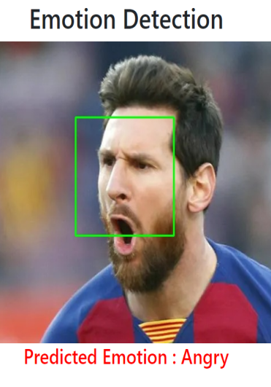 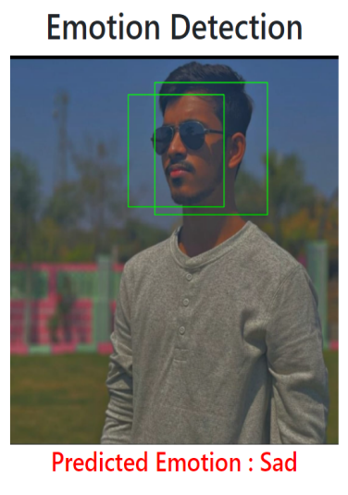 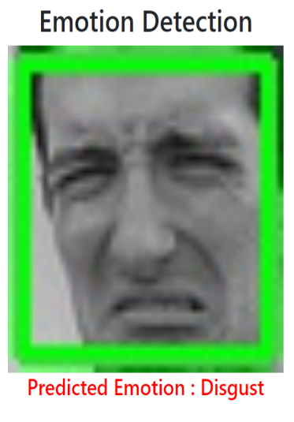 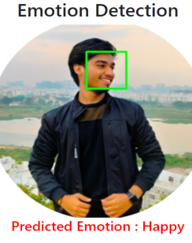 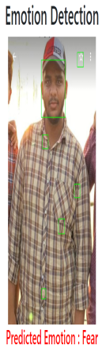 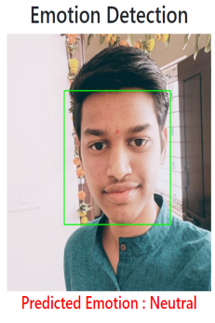 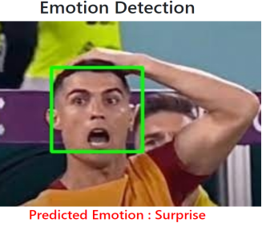

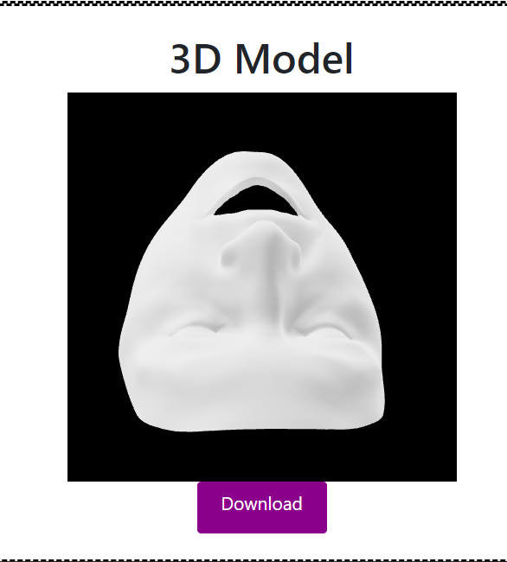

CHAPTER 4–RESULTS

The following are the results obtained after implementation–

1. Initial welcome page–

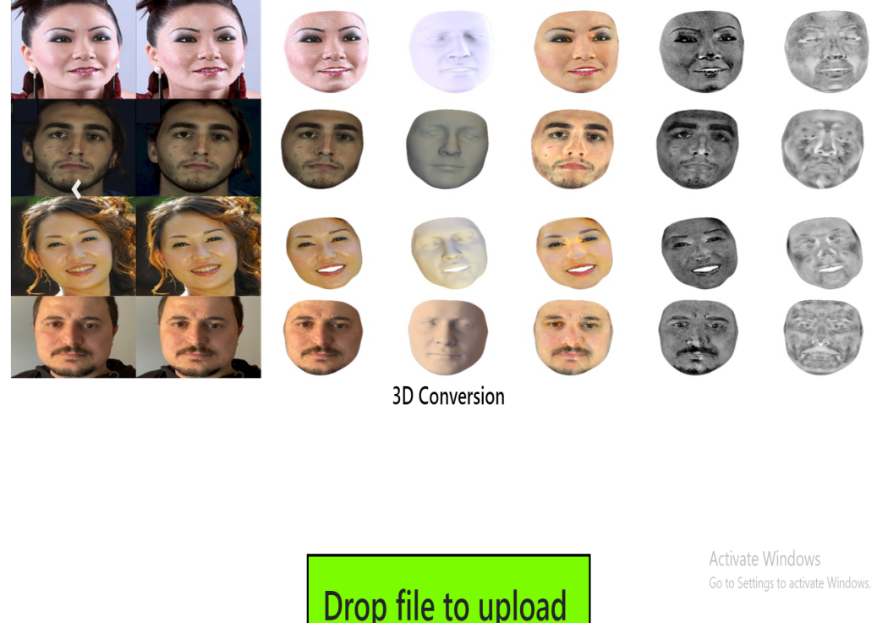

1. About Us Page--

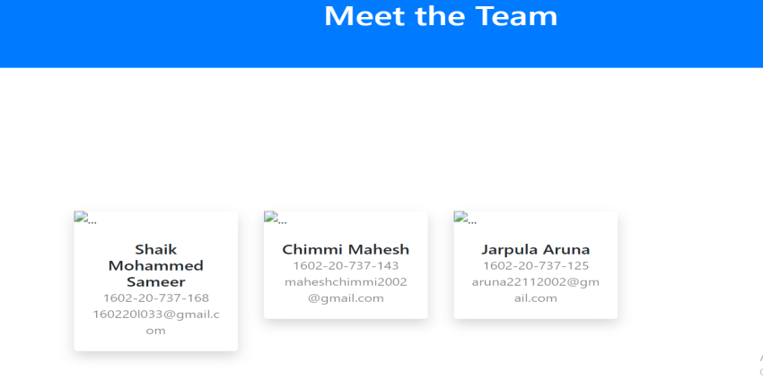

1. Contact Page--

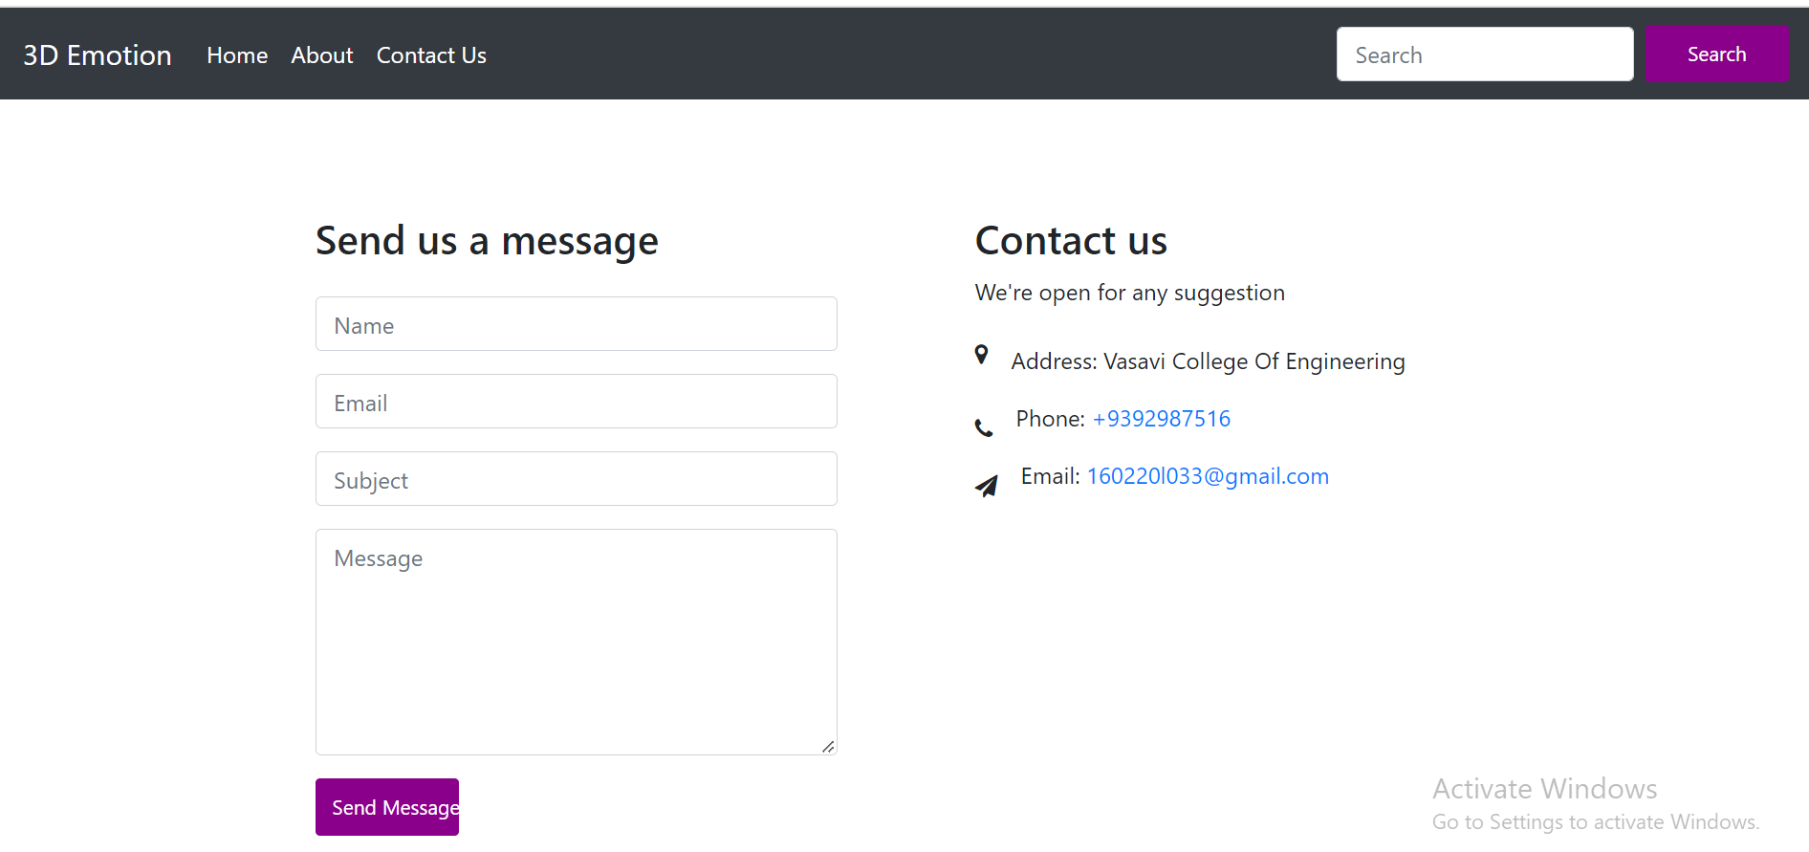

1. Prediction Page--

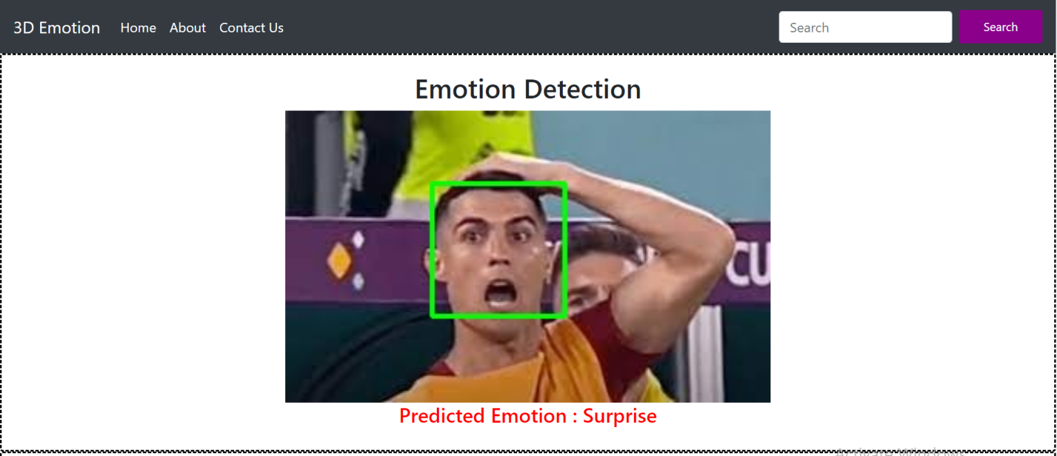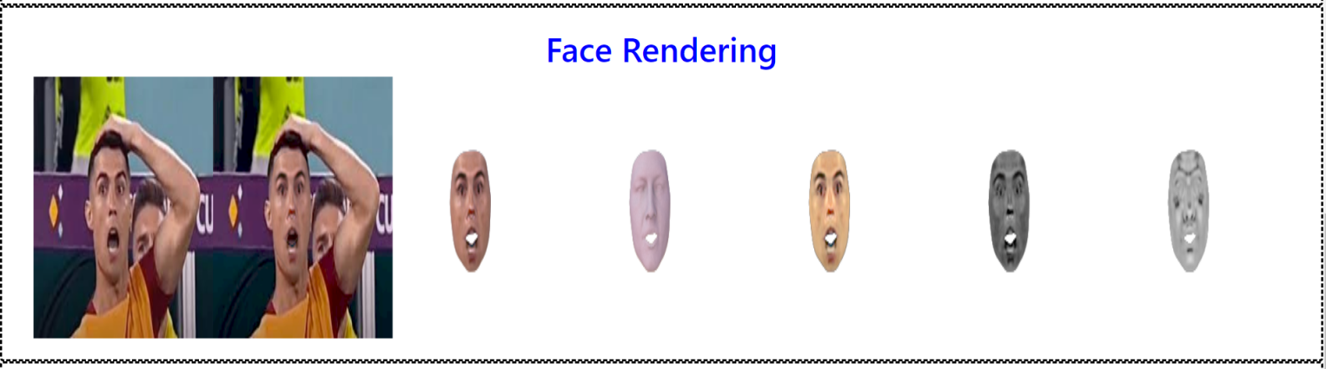



**CHAPTER 5**

**DISCUSSION AND FUTURE WORK –**

* The project can be further extended by developing an API.
* Improving 3d model efficiency.
* Auto rotation of 3d face.

CHAPTER 6 REFERENCES–

* <https://www.kaggle.com/datasets/msambare/fer2013>
* <https://towardsdatascience.com/a-comprehensive-guide-to-convolutional-neural-networks-the-eli5-way-3bd2b1164a53>
* <https://www.javatpoint.com/keras>
* <https://www.geeksforgeeks.org/opencv-python-tutorial/>
* <https://faces.dmi.unibas.ch/bfm/bfm2017.html>
* <https://www.tutorialspoint.com/flask/index.html>